English Circle Application

November

What do we do:
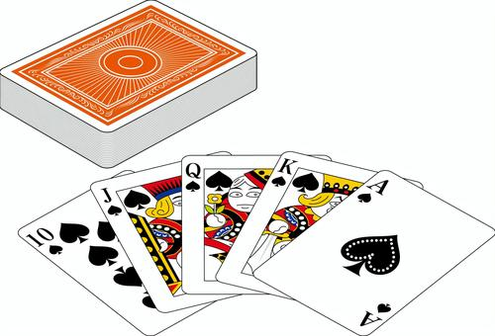
- play games.
- watch videos or listen to music.
- practice Eiken speaking tests.
- practice for speech contests.

Where? Second floor study room.
How Long? 20~30 minutes.
When? After classes, before club activities.

Date Activities Date Activities
11/6 Eiken 3級 11/28 Music/Videos (生徒議会あり)
11/7 Eiken 3級 11/30 English Games

cut here✂
_ _ _ _ _ _ _ _ _ _ _ _ _ _ _ _ _ _ _ _ _ _ _ _ _ _ _ _ _ _ _ _ _ _ _
I am interested in English Circle on the following dates: [for John]
(Check as many as you want)
□ 11/6 □ 11/7 □ 11/28 □ 11/30

Name[ローマ字]:__________________________________
cut here✂
Class:______–______
_ _ _ _ _ _ _ _ _ _ _ _ _ _ _ _ _ _ _ _ _ _ _ _ _ _ _ _ _ _ _ _ _ _ _ _ _ _ _ _ _ _
I am interested in English Circle on the following dates: [for teacher]
(Check as many as you want)
□ 11/6 □ 11/7 □ 11/28 □ 11/30

Name:______________________________________

Class:______–______

English Circle Application

November
What do we do:
- play games.
- watch videos or listen to music.
- practice Eiken speaking tests.
- practice for speech contests.
Where? Second floor study room.
How Long? 20~30 minutes.
When? After classes, before club activities.
Date Activities Date Activities
11/6 Eiken 3級 11/28 Music/Videos (生徒議会あり)
11/7 Eiken 3級 11/30 English Games

cut here✂
_ _ _ _ _ _ _ _ _ _ _ _ _ _ _ _ _ _ _ _ _ _ _ _ _ _ _ _ _ _ _ _ _ _ _
I am interested in English Circle on the following dates: [for John]
(Check as many as you want)
□ 11/6 □ 11/7 □ 11/28 □ 11/30

Name[ローマ字]:__________________________________
cut here✂
Class:______–______
_ _ _ _ _ _ _ _ _ _ _ _ _ _ _ _ _ _ _ _ _ _ _ _ _ _ _ _ _ _ _ _ _ _ _ _ _ _ _ _ _ _
I am interested in English Circle on the following dates: [for teacher]
(Check as many as you want)
□ 11/6 □ 11/7 □ 11/28 □ 11/30

Name:______________________________________

Class:______–______

English Circle Application

November
What do we do:
- play games.
- watch videos or listen to music.
- practice Eiken speaking tests.
- practice for speech contests.
Where? Second floor study room.
How Long? 20~30 minutes.
When? After classes, before club activities.

Date Activities Date Activities
11/6 Eiken 3級 11/28 Music/Videos (生徒議会あり)
11/7 Eiken 3級 11/30 English Games

cut here✂
_ _ _ _ _ _ _ _ _ _ _ _ _ _ _ _ _ _ _ _ _ _ _ _ _ _ _ _ _ _ _ _ _ _ _
I am interested in English Circle on the following dates: [for John]
(Check as many as you want)
□ 11/6 □ 11/7 □ 11/28 □ 11/30

Name[ローマ字]:__________________________________
cut here✂
Class:______–______
_ _ _ _ _ _ _ _ _ _ _ _ _ _ _ _ _ _ _ _ _ _ _ _ _ _ _ _ _ _ _ _ _ _ _ _ _ _ _ _ _ _
I am interested in English Circle on the following dates: [for teacher]
(Check as many as you want)
□ 11/6 □ 11/7 □ 11/28 □ 11/30

Name:______________________________________

Class:______–______

English Circle Application

November
What do we do:
- play games.
- watch videos or listen to music.
- practice Eiken speaking tests.
- practice for speech contests.
Where? Second floor study room.
How Long? 20~30 minutes.
When? After classes, before club activities.
Date Activities Date Activities
11/6 Eiken 3級 11/28 Music/Videos (生徒議会あり)
11/7 Eiken 3級 11/30 English Games

cut here✂
_ _ _ _ _ _ _ _ _ _ _ _ _ _ _ _ _ _ _ _ _ _ _ _ _ _ _ _ _ _ _ _ _ _ _
I am interested in English Circle on the following dates: [for John]
(Check as many as you want)
□ 11/6 □ 11/7 □ 11/28 □ 11/30

Name[ローマ字]:__________________________________
cut here✂
Class:______–______
_ _ _ _ _ _ _ _ _ _ _ _ _ _ _ _ _ _ _ _ _ _ _ _ _ _ _ _ _ _ _ _ _ _ _ _ _ _ _ _ _ _
I am interested in English Circle on the following dates: [for teacher]
(Check as many as you want)
□ 11/6 □ 11/7 □ 11/28 □ 11/30

Name:______________________________________

Class:______–______

