**English Circle Application**

March



What do we do:

* play games.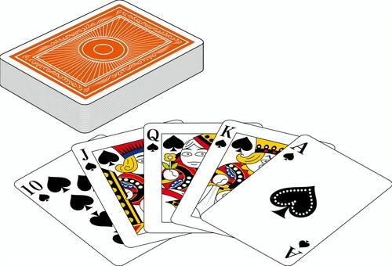
* watch videos or listen to music.
* practice Eiken speaking tests.
* practice for speech contests.



Where? Second floor study room.

How Long? 20~30 minutes.

When? After classes, before club activities.

Date Activities Date Activities

03/11 English Video&Music 03/14 Games and Conversation

03/13 Games and Conversation

cut here✂

_ _ _ _ _ _ _ _ _ _ _ _ _ _ _ _ _ _ _ _ _ _ _ _ _ _ _ _ _ _ _ _ _ _ _

I am interested in English Circle on the following dates: [for John]

(Check as many as you want)

**□** 03/11 □ 03/13 □ 03/14

Name[**ローマ字**]:__________________________________

cut here✂

Class:______–______

_ _ _ _ _ _ _ _ _ _ _ _ _ _ _ _ _ _ _ _ _ _ _ _ _ _ _ _ _ _ _ _ _ _ _ _ _ _ _ _ _ _

I am interested in English Circle on the following dates: [for teacher]

(Check as many as you want)

**□** 03/11 □ 03/13 □ 03/14

Name:______________________________________

Class:______–______

**English Circle Application**

March



What do we do:

* play games.
* watch videos or listen to music.
* practice Eiken speaking tests.
* practice for speech contests.



Where? Second floor study room.

How Long? 20~30 minutes.

When? After classes, before club activities.

Date Activities Date Activities

03/11 English Video&Music 03/14 Games and Conversation

03/13 Games and Conversation

cut here✂

_ _ _ _ _ _ _ _ _ _ _ _ _ _ _ _ _ _ _ _ _ _ _ _ _ _ _ _ _ _ _ _ _ _ _

I am interested in English Circle on the following dates: [for John]

(Check as many as you want)

**□** 03/11 □ 03/13 □ 03/14

Name[**ローマ字**]:__________________________________

cut here✂

Class:______–______

_ _ _ _ _ _ _ _ _ _ _ _ _ _ _ _ _ _ _ _ _ _ _ _ _ _ _ _ _ _ _ _ _ _ _ _ _ _ _ _ _ _

I am interested in English Circle on the following dates: [for teacher]

(Check as many as you want)

**□** 03/11 □ 03/13 □ 03/14

Name:______________________________________

Class:______–______

**English Circle Application**

March



What do we do:

* play games.
* watch videos or listen to music.
* practice Eiken speaking tests.
* practice for speech contests.



Where? Second floor study room.

How Long? 20~30 minutes.

When? After classes, before club activities.

Date Activities Date Activities

03/11 English Video&Music 03/14 Games and Conversation

03/13 Games and Conversation

cut here✂

_ _ _ _ _ _ _ _ _ _ _ _ _ _ _ _ _ _ _ _ _ _ _ _ _ _ _ _ _ _ _ _ _ _ _

I am interested in English Circle on the following dates: [for John]

(Check as many as you want)

**□** 03/11 □ 03/13 □ 03/14

Name[**ローマ字**]:__________________________________

cut here✂

Class:______–______

_ _ _ _ _ _ _ _ _ _ _ _ _ _ _ _ _ _ _ _ _ _ _ _ _ _ _ _ _ _ _ _ _ _ _ _ _ _ _ _ _ _

I am interested in English Circle on the following dates: [for teacher]

(Check as many as you want)

**□** 03/11 □ 03/13 □ 03/14

Name:______________________________________

Class:______–______

**English Circle Application**

March



What do we do:

* play games.
* watch videos or listen to music.
* practice Eiken speaking tests.
* practice for speech contests.



Where? Second floor study room.

How Long? 20~30 minutes.

When? After classes, before club activities.

Date Activities Date Activities

03/11 English Video&Music 03/14 Games and Conversation

03/13 Games and Conversation

cut here✂

_ _ _ _ _ _ _ _ _ _ _ _ _ _ _ _ _ _ _ _ _ _ _ _ _ _ _ _ _ _ _ _ _ _ _

I am interested in English Circle on the following dates: [for John]

(Check as many as you want)

**□** 03/11 □ 03/13 □ 03/14

Name[**ローマ字**]:__________________________________

cut here✂

Class:______–______

_ _ _ _ _ _ _ _ _ _ _ _ _ _ _ _ _ _ _ _ _ _ _ _ _ _ _ _ _ _ _ _ _ _ _ _ _ _ _ _ _ _

I am interested in English Circle on the following dates: [for teacher]

(Check as many as you want)

**□** 03/11 □ 03/13 □ 03/14

Name:______________________________________

Class:______–______